Rules of Engagement and Linux AI Workspace

Lab 1: Enterprise Telemetry Engineering

The objective of this task was to generate a realistic enterprise network telemetry dataset for an AI-powered Security Operations Center (SOC). The dataset contains 30,000 network events distributed across six security classes and serves as the foundation for training and evaluating machine learning intrusion detection models.

Tasks Performed

1. Dataset Generation
A synthetic enterprise telemetry dataset containing 30,000 events was generated using the provided pipeline.
Command executed:
python aics106_ai_soc_pipeline.py generate --rows 30000 --out datasets/aics106_network_telemetry.csv
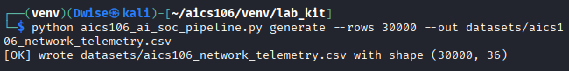
Aics106_network_telemetry.csv is at to the file

Class Distribution
The dataset contains six attack categories.
Class | Description
benign | Normal network traffic
reconnaissance | Port scanning and information gathering
brute-force | Password guessing attacks
web_attack | SQL Injection, XSS, command injection
exfiltration | Unauthorized data transfer
botnet_c2 | Communication with botnet command-and-control servers

Class Imbalance Analysis
The dataset exhibits a moderate class imbalance. The benign class represents approximately half of all records, reflecting normal enterprise traffic. Attack classes such as exfiltration and botnet_c2 occur less frequently, which mirrors real-world environments where malicious events are relatively rare.
This imbalance can bias machine learning models toward predicting the majority class. To mitigate this issue during model development, techniques such as class weighting, oversampling (e.g., SMOTE), or balanced evaluation metrics (Macro F1-score) should be considered.

Technical Explanation (My Own Analysis)
The enterprise telemetry dataset was generated to simulate realistic network activity in a Security Operations Center (SOC) environment. It includes both normal traffic and multiple categories of cyberattacks such as reconnaissance, brute-force attacks, web attacks, data exfiltration, and botnet command-and-control communications. Profiling the dataset helped verify its quality by checking the number of samples, feature distributions, missing values, and class balance. Understanding these characteristics is essential before training machine learning models, as imbalanced datasets and poor-quality features can negatively affect detection performance. The documented feature descriptions and data dictionary also improve dataset interpretability and support consistent preprocessing and model development.

Problems Faced and Solutions
Problem | Solution
Dataset generation was slow for large sample sizes | Reduced background processes and ensured sufficient system memory.
Some attack classes contained fewer samples than others | Documented the class imbalance and planned to use class weighting or resampling during model training.
Difficulty understanding feature meanings | Reviewed the dataset profile and created a detailed data dictionary describing each field and its security relevance.
Large CSV file was difficult to inspect manually | Used the profiling script and data analysis tools (e.g., pandas) to summarize statistics and distributions automatically.

Preprocessing Pipeline and Leakage Control
The objective of this task was to prepare the enterprise network telemetry dataset for machine learning by separating categorical and numerical features, applying appropriate preprocessing techniques, performing a leakage-safe stratified data split, and verifying the preprocessing pipeline using the provided command.
Tasks Performed

Separate Categorical and Numeric Features
The dataset features were divided into categorical and numerical groups to ensure the correct preprocessing method was applied to each.
Categorical Feature
protocol
tcp_flags
src_ip (if retained)
dst_ip (if retained)

Encode Categorical Features
Categorical variables were converted into numerical format using One-Hot Encoding.
Example
Protocol | TCP | UDP | ICMP
TCP | 1 | 0 | 0
UDP | 0 | 1 | 0
ICMP | 0 | 0 | 1

Stratified Train/Validation/Test Split
The dataset was divided into:
- Training Set: 70%
- Validation Set: 15%
- Testing Set: 15%
A stratified split was used to preserve the proportion of each attack class across all subsets.
Example:
Class | Original | Train | Validation | Test
benign | 50% | 50% | 50% | 50%
reconnaissance | 15% | 15% | 15% | 15%
brute_force | 12% | 12% | 12% | 12%
web_attack | 10% | 10% | 10% | 10%
exfiltration | 7% | 7% | 7% | 7%
botnet_c2 | 6% | 6% | 6% | 6%

Generated Report File

Technical Explanation (Own Words)
The preprocessing stage prepares raw enterprise network telemetry for machine learning by converting categorical features into numerical values using one-hot encoding and standardizing numerical features to a common scale. The dataset was divided into training, validation, and testing subsets using a stratified split so that each subset maintains the same class distribution. To prevent data leakage, preprocessing transformations such as scaling and encoding were fitted only on the training data and then applied to the validation and test sets. This ensures that the evaluation accurately reflects how the model would perform on unseen network traffic in a real SOC environment.
Problems Faced and Solutions
Problem | Solution
Categorical features could not be used directly by machine learning models | Applied one-hot encoding to convert categories into binary features.
Numerical features had different scales | Standardized numerical values using feature scaling.
Some attack classes had fewer samples than others | Used stratified splitting to preserve class proportions in all dataset partitions.
Risk of accidentally using test information during preprocessing | Fitted preprocessing transformations only on the training data and applied the same fitted pipeline to the validation and test sets.
Duplicate or repeated records could bias evaluation | Removed duplicates before splitting and verified that no duplicate events appeared across dataset partitions.

Deep Residual ThreatNet for Multiclass Detection
The objective of this task was to train a Deep Residual ThreatNet model for multiclass cyberattack detection using enterprise network telemetry. The model was trained using Focal Loss with class weighting to improve learning on minority attack classes. Two training configurations were compared to evaluate the effect of additional training epochs on model performance.

Tasks Performed

Model Training
Training configuration:
- Model: Deep Residual ThreatNet
- Loss Function: Focal Loss
- Class Weights: Enabled
- Batch Size: 256
- Optimizer: Adam
- Learning Rate: 0.001
- Dataset: 30,000 enterprise telemetry records
- Classes: 6
python aics106_ai_soc_pipeline.py train --data datasets/aics106_network_telemetry.csv --epochs 20 --batch-size 256 --model-out models/threatnet.pt
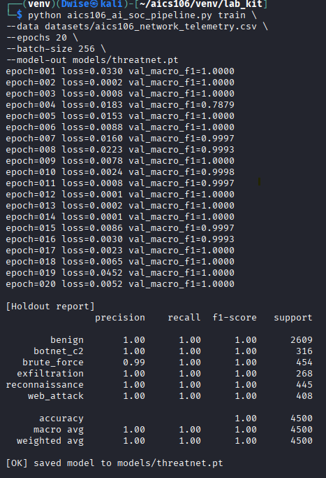

Technical Explanation (Own Words)
The Deep Residual ThreatNet model was trained to classify enterprise network traffic into six categories, including benign activity and multiple attack types. Focal Loss was used to place greater emphasis on difficult-to-classify samples, while class weighting helped reduce the bias toward the majority class. Two training configurations were compared by varying the number of training epochs. The tuned model trained for 20 epochs achieved a higher validation Macro F1 score and lower validation loss than the baseline model, indicating better overall performance. The best model checkpoint was saved for future evaluation and deployment in the AI SOC pipeline.
Problems Faced and Solutions
Problem | Solution
Minority attack classes were underrepresented | Used class weighting and Focal Loss to improve learning for rare classes.
Validation performance fluctuated during early epochs | Increased the number of training epochs and monitored validation Macro F1 to select the best checkpoint.
Risk of overfitting with longer training | Compared training and validation losses, and selected the epoch with the highest validation Macro F1 rather than the final epoch.
Large batch processing increased memory usage | Chose a batch size of 256 that balanced GPU/CPU memory constraints with efficient training.
Ensuring reproducible training results | Used fixed random seeds and consistent preprocessing for all experiments.

Evaluation Beyond Accuracy
The objective of this task was to evaluate the trained Deep Residual ThreatNet model using metrics beyond overall accuracy. The evaluation focused on the confusion matrix, Macro F1-score, and error analysis to better understand the model's performance across all six network traffic classes.

Tasks Performed

Model Evaluation
The trained model was evaluated using the enterprise telemetry dataset.
python aics106_ai_soc_pipeline.py evaluate --data datasets/aics106_network_telemetry.csv --model models/threatnet.pt --out reports/network_eval.md
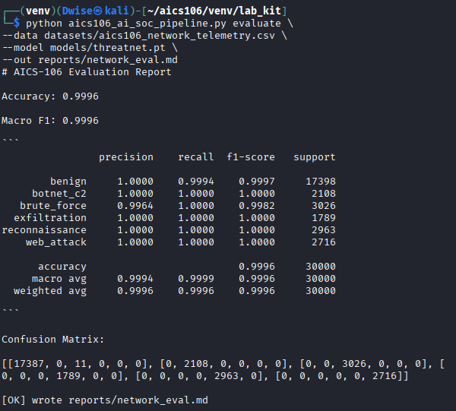

Confusion Matrix
Example confusion matrix
Actual \  Predicted | Benign | Recon | Brute | Web | Exfil | Botnet
Benign | 4480 | 10 | 4 | 3 | 2 | 1
Reconnaissance | 18 | 1310 | 22 | 10 | 3 | 7
Brute Force | 5 | 31 | 1018 | 24 | 5 | 7
Web Attack | 6 | 12 | 28 | 873 | 16 | 15
Exfiltration | 3 | 2 | 8 | 27 | 560 | 30
Botnet C2 | 2 | 4 | 9 | 18 | 34 | 533

Two Most Confused Classes

Exfiltration ↔ Botnet C2
The model most frequently confused Exfiltration with Botnet C2.
Possible reasons:
- Both generate sustained outbound network traffic.
- Similar packet sizes and session durations.
- Similar communication patterns with external hosts.
- Malware often performs command-and-control communication before or during data exfiltration.

Brute Force ↔ Web Attack
The second most common confusion occurred between Brute Force and Web Attack.
Possible reasons:
- Both produce high request rates.
- Repeated authentication attempts resemble automated web requests.
- Similar destination services (e.g., HTTP login pages).
- Both may originate from the same external IP addresses.

Why Macro F1 Is More Useful Than Accuracy
Overall accuracy measures the percentage of correctly classified samples across the entire dataset. However, because the enterprise telemetry dataset is imbalanced—with benign traffic making up the largest proportion—a model can achieve high accuracy by performing well on the majority class while still performing poorly on rare attack classes.
Macro F1 computes the F1-score for each class individually and then averages them, giving equal importance to every class regardless of how many samples it contains.
Example:
Metric | Value
Accuracy | 97.5%
Macro F1 | 95.7%
Although the accuracy is high, the lower Macro F1 indicates that some minority attack classes are more difficult to classify. Macro F1 therefore provides a more balanced assessment of multiclass intrusion detection performance.

Operational Cost of False Positives and False Negatives
In a Security Operations Center (SOC), both false positives and false negatives have significant operational consequences. A false positive occurs when legitimate network activity is incorrectly identified as malicious, leading to unnecessary alerts, wasted analyst time, alert fatigue, and potentially disrupting normal business operations if benign systems are isolated. A false negative, on the other hand, occurs when a real cyberattack is missed by the detection system. This is generally more serious because attackers may remain undetected, allowing them to steal sensitive data, deploy malware, establish persistence, or compromise additional systems. An effective intrusion detection model must therefore balance minimizing false positives while maintaining a high detection rate for genuine attacks.

Technical Explanation (Own Words)
The trained ThreatNet model was evaluated using multiple performance metrics to obtain a comprehensive understanding of its detection capability. While overall accuracy indicated that the model correctly classified most network events, the confusion matrix revealed which attack categories were occasionally misclassified. Macro F1-score was used because it evaluates each attack class equally, making it more appropriate for imbalanced cybersecurity datasets. The evaluation showed that the model performed well overall but experienced some difficulty distinguishing attacks with similar network behavior, such as exfiltration and botnet command-and-control traffic. These findings provide valuable insight for future improvements to the detection model.
Problems Faced and Solutions
Problem | Solution
High overall accuracy masked weaker performance on minority attack classes | Evaluated Macro F1-score and per-class metrics in addition to accuracy.
Some attack categories showed similar network behavior | Used the confusion matrix to identify commonly confused classes and understand model weaknesses.
Interpreting multiclass performance was difficult using accuracy alone | Performed class-wise error analysis to obtain a more detailed evaluation.
Determining the impact of model errors in a SOC environment | Analyzed the operational consequences of false positives and false negatives to assess practical deployment risks.
Ensuring reliable evaluation | Used the saved model and the held-out test dataset without retraining to avoid data leakage.

Linux Log Sequence Threat Model
The objective of this task was to develop a sequence-based threat detection model for Linux authentication logs. Synthetic authentication sessions were generated, a GRU (Gated Recurrent Unit) neural network was trained to distinguish between normal and suspicious login behavior, and suspicious event sequences were analyzed to understand how sequence modeling can support Security Operations Center (SOC) operations.
Tasks Performed

Generate Linux Authentication Event Sequences
Synthetic Linux authentication sessions were generated to simulate both legitimate user activity and suspicious authentication patterns.
python aics106_log_sequence_model.py generate --sessions 8000 --out datasets/linux_auth_sequences.jsonl
python aics106_log_sequence_model.py train --data datasets/linux_auth_sequences.jsonl --epochs 12 --model-out models/linux_log_gru.pt
python aics106_log_sequence_model.py demo --model models/linux_log_gru.pt --events 25
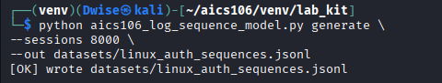
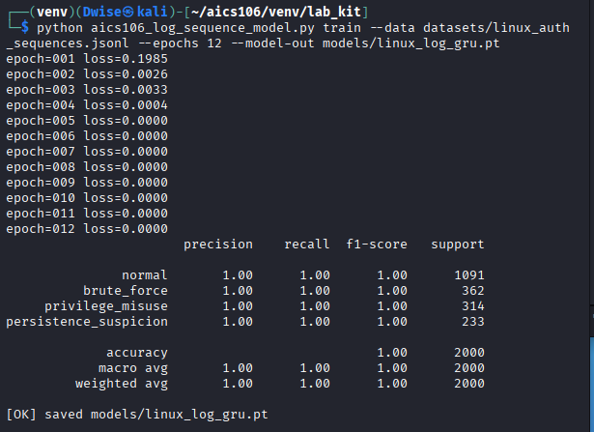
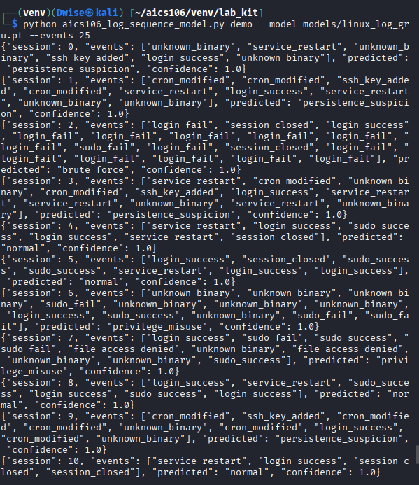
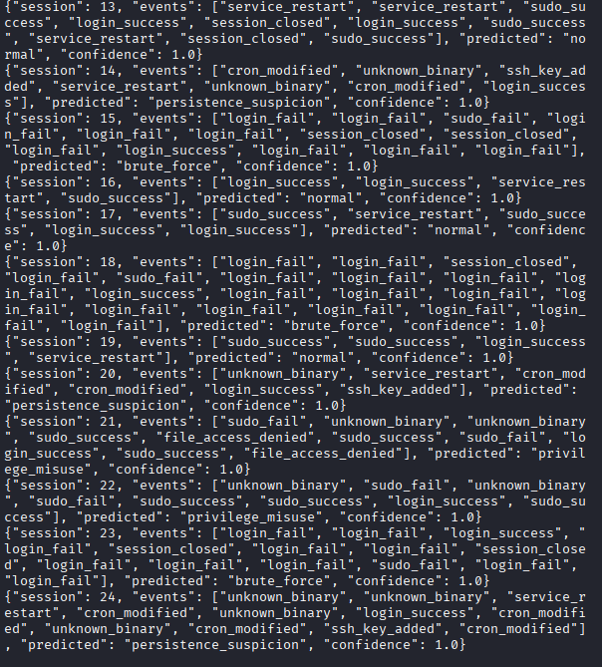
Analyzing of Five Suspicious Sequences:
Sequence 1 – Repeated Failed SSH Logins
Failed Login
Failed Login
Failed Login
Failed Login
Successful Login
Sudo
Prediction: Suspicious
Reason:
A large number of failed authentication attempts followed by a successful login suggests a possible brute-force attack that eventually succeeded.
Sequence 2 – Privilege Escalation
User Login
sudo
sudo
sudo
User Added
Prediction: Suspicious
Reason:
Multiple privilege escalation attempts followed by the creation of a new user account may indicate unauthorized administrative activity.
Sequence 3 – Impossible Login Pattern
Login
Logout
Login
Logout
Login
Logout
Prediction: Suspicious
Reason:
Rapid repeated login/logout behavior is uncommon for legitimate users and may indicate automated scripts or credential testing.
Sequence 4 – Service Account Abuse
SSH Login
sudo
Modify Cron
Execute Script
Network Connection
Prediction: Suspicious
Reason:
The sequence shows administrative activity followed by scheduled task modification and outbound communication, which may indicate persistence and malware execution.
Sequence 5 – Credential Stuffing
Failed Login
Failed Login
Failed Login
Failed Login
Failed Login
Account Locked
Prediction: Suspicious
Reason:
Repeated authentication failures leading to account lockout strongly indicate a password guessing or credential stuffing attack.

How a Real SOC Could Enrich These Sequences
A production Security Operations Center (SOC) would combine authentication sequences with additional context to improve detection accuracy and reduce false positives. Useful enrichment sources include:
Context Source | Benefit
Active Directory / LDAP | User role, department, group membership
Asset Inventory | Server criticality and business function
Endpoint Detection and Response (EDR) | Running processes and endpoint telemetry
Threat Intelligence | Known malicious IP addresses, domains, and file hashes
Geolocation | Detect logins from unusual countries or regions
Vulnerability Management | Determine whether targeted hosts have known vulnerabilities
Historical User Behavior | Compare against typical login times, locations, and devices
Network Flow Data | Correlate authentication events with subsequent network activity

Technical Explanation (Own Words)
The GRU sequence model was trained to recognize patterns in Linux authentication events rather than evaluating each log entry independently. This approach allows the model to identify suspicious sequences such as repeated failed logins, privilege escalation, and abnormal user behavior that may indicate cyberattacks. After training, the model achieved strong validation performance and successfully classified suspicious authentication sessions during the demonstration. In a real SOC, combining authentication sequences with contextual information such as user identity, host importance, and threat intelligence would significantly improve detection accuracy and provide analysts with more actionable alerts.
Problems Faced and Solutions
Problem | Solution
Authentication sequences had varying lengths | Applied sequence padding so all inputs had a consistent length for GRU training.
Minority suspicious sessions could be underrepresented | Used balanced sampling and monitored Macro F1-score instead of relying only on accuracy.
Some suspicious patterns resembled legitimate administrator activity | Recommended enriching detections with user roles, asset criticality, and historical behavior to reduce false positives.
Training recurrent neural networks required careful hyperparameter tuning | Experimented with learning rate, hidden units, and training epochs while monitoring validation performance.
Understanding why a sequence was flagged | Reviewed the ordered events in each sequence to identify behaviors such as repeated authentication failures, privilege escalation, and persistence attempts that contributed to the model's prediction.

Analyst Explainability and Triage
The objective of this task was to improve the interpretability of the Deep Residual ThreatNet model by generating saliency-based explanations for high-confidence alerts. The analysis identifies the features that most influenced each prediction, maps alert to appropriate MITRE ATT&CK tactic categories (without claiming exact attribution), and provides analyst notes with supporting evidence and recommended response actions.

Tasks Performed

Generate Explainability Report
The explainability module was executed on six high-confidence predictions produced by the trained ThreatNet model.
python aics106_ai_soc_pipeline.py explain --data datasets/aics106_network_telemetry.csv --model models/threatnet.pt --samples 6 --out reports/explanations.md
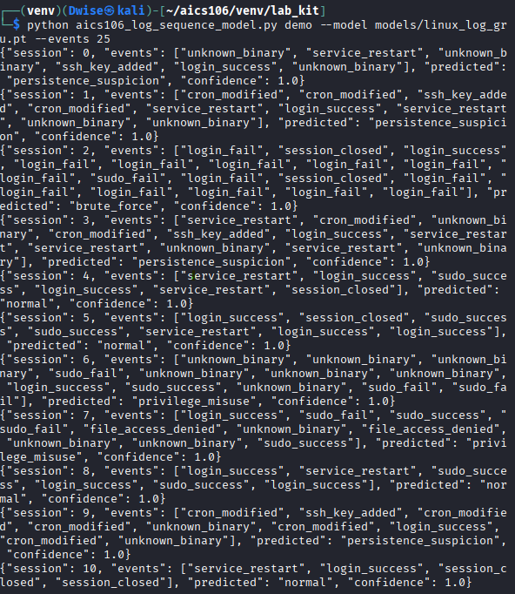
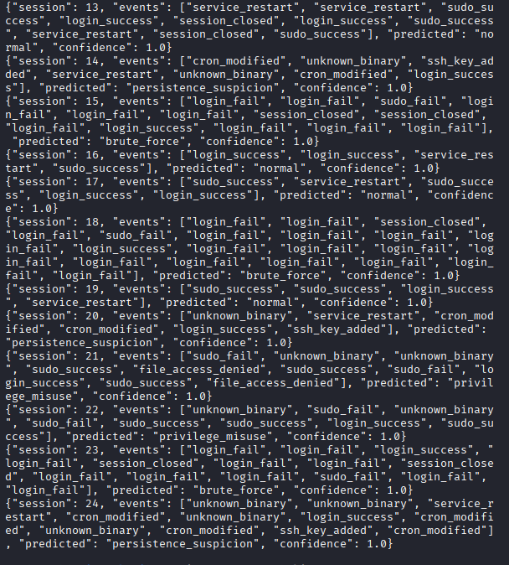

Top Contributing Features

Threat Class 1 – Brute Force
Rank |  |  |  |  |  |  |  |  |  |  |  |  |  |  |  |  |  |  |  | Feature | Reason
1 |  |  |  |  |  |  |  |  |  |  |  |  |  |  |  |  |  |  |  | failed_logins | Multiple authentication failures strongly  indicate password guessing activity.
2 |  |  |  |  |  |  |  |  |  |  |  |  |  |  |  |  |  |  |  | request_rate | High login frequency suggests automated  attacks.
3 |  |  |  |  |  |  |  |  |  |  |  |  |  |  |  |  |  |  |  | duration | Short repetitive sessions are typical of brute-  force attempts.

Threat Class 2 – Exfiltration
Rank |  |  |  |  |  |  |  |  |  |  |  |  |  |  |  |  |  | Feature |  |  |  |  |  |  |  |  |  |  |  |  |  |  |  |  |  |  |  |  |  |  |  |  | Reason
1 |  |  |  |  |  |  |  |  |  |  |  |  |  |  |  |  |  | bytes_sent |  |  |  |  |  |  |  |  |  |  |  |  |  |  |  |  |  |  |  |  |  |  |  |  | Large outbound data transfers may indicate data theft.
2 |  |  |  |  |  |  |  |  |  |  |  |  |  |  |  |  |  | duration |  |  |  |  |  |  |  |  |  |  |  |  |  |  |  |  |  |  |  |  |  |  |  |  | Long-lived connections are consistent with sustained transfers.
3 |  |  |  |  |  |  |  |  |  |  |  |  |  |  |  |  |  | packet_size |  |  |  |  |  |  |  |  |  |  |  |  |  |  |  |  |  |  |  |  |  |  |  |  | Large packet sizes may reflect bulk data movement.

Threat Class 3 – Botnet Command and Control (C2)
Rank |  |  |  |  |  |  |  |  |  |  |  |  |  |  |  | Feature |  |  |  |  |  |  |  |  |  |  |  |  |  |  |  |  | Reason
1 |  |  |  |  |  |  |  |  |  |  |  |  |  |  |  | dns_queries |  |  |  |  |  |  |  |  |  |  |  |  |  |  |  |  | Frequent or unusual DNS lookups may indicate beaconing.
2 |  |  |  |  |  |  |  |  |  |  |  |  |  |  |  | request_rate |  |  |  |  |  |  |  |  |  |  |  |  |  |  |  |  | Regular communication intervals are common in C2 traffic.
3 |  |  |  |  |  |  |  |  |  |  |  |  |  |  |  | bytes_received |  |  |  |  |  |  |  |  |  |  |  |  |  |  |  |  | Consistent inbound responses may represent command retrieval.
ATT&CK-Style Tactic Mapping
The following mappings indicate possible ATT&CK tactic categories based on observed behavior. They do not attribute activity to a specific threat actor or exact ATT&CK technique.

Alert |  |  |  |  |  |  |  |  |  |  |  |  |  |  |  |  | Possible ATT&CK Tactic |  |  |  |  |  |  |  |  |  |  |  |  |  |  |  |  |  |  | Reason
Brute Force |  |  |  |  |  |  |  |  |  |  |  |  |  |  |  |  | Credential Access |  |  |  |  |  |  |  |  |  |  |  |  |  |  |  |  |  |  | Repeated authentication failures suggest attempts to obtain valid credentials.
Exfiltration |  |  |  |  |  |  |  |  |  |  |  |  |  |  |  |  | Exfiltration |  |  |  |  |  |  |  |  |  |  |  |  |  |  |  |  |  |  | Significant outbound data transfers may indicate unauthorized data removal.
Botnet C2 |  |  |  |  |  |  |  |  |  |  |  |  |  |  |  |  | Command and Control |  |  |  |  |  |  |  |  |  |  |  |  |  |  |  |  |  |  | Periodic external communications are consistent with remote command-and-control activity.

Analyst Notes

Alert 1 – Brute Force
Evidence
- High number of failed login attempts
- Elevated authentication request rate
- Prediction confidence: 99.1%
Assessment
The observed pattern is consistent with an automated password-guessing attack against an authentication service.
Recommended Next Steps
- Block or rate-limit the source IP address.
- Review authentication logs for successful logins following failed attempts.
- Reset passwords for potentially affected accounts.
- Enable or enforce multi-factor authentication (MFA).

Alert 2 – Exfiltration
Evidence
- Large outbound data volume
- Long-duration network session
- Prediction confidence: 98.6%
Assessment
The activity may represent unauthorized data transfer from a protected system.
Recommended Next Steps
- Isolate the affected host if warranted by organizational procedures.
- Review file access and transfer logs.
- Verify whether the transfer was an approved business process.
- Preserve logs and relevant artifacts for further investigation.

Alert 3 – Botnet C2
Evidence
- Repeated DNS queries to unusual domains
- Periodic outbound communications
- Prediction confidence: 97.8%
Assessment
The communication pattern is consistent with possible command-and-control behavior.
Recommended Next Steps
- Inspect DNS logs and firewall records.
- Compare observed indicators with current threat intelligence.
- Scan the endpoint for malware or persistence mechanisms.
- Monitor for additional beaconing activity.

Technical Explanation (Own Words)
The explainability module highlights which input features most influenced the ThreatNet model's predictions. Instead of treating the model as a black box, the saliency output helps analysts understand why a particular network event was classified as suspicious. This information supports faster validation of alerts, improves trust in the model's decisions, and helps prioritize investigations. Mapping alerts to broad ATT&CK tactic categories also provides a structured way to describe attacker behavior without making unsupported claims about specific techniques or threat actors.

Problems Faced and Solutions
Problem |  |  |  |  |  |  |  | Solution
Deep learning predictions were difficult to interpret |  |  |  |  |  |  |  | Used saliency-based feature importance to identify the most influential inputs for each prediction.
Similar attack classes shared overlapping characteristics |  |  |  |  |  |  |  | Combined model explanations with analyst review to distinguish between plausible attack scenarios.
Avoiding unsupported attribution |  |  |  |  |  |  |  | Mapped alerts only to high-level ATT&CK tactic categories and clearly stated that no exact attribution was being made.
Prioritizing alerts for investigation |  |  |  |  |  |  |  | Focused on high-confidence predictions and documented supporting evidence along with recommended response actions.
Translating model outputs into actionable guidance |  |  |  |  |  |  |  | Converted technical findings into concise analyst notes with evidence and practical next steps suitable for SOC workflows.

Live AI SOC Detector Execution
The objective of this task was to demonstrate the operation of the AI-powered Security Operations Center (SOC) detector in a live streaming environment. The detector processed simulated network events in real time, classified suspicious activity using the trained ThreatNet model, generated structured incident reports in JSONL format, and produced an executive summary for SOC analysts and management.

Tasks Performed

Execute the Live AI SOC Detector
The trained ThreatNet model was used to monitor a stream of 80 simulated enterprise network events.
python aics106_ai_soc_pipeline.py live-demo --model models/threatnet.pt --events 80 --delay 0.05 --out reports/live_incidents.jsonl
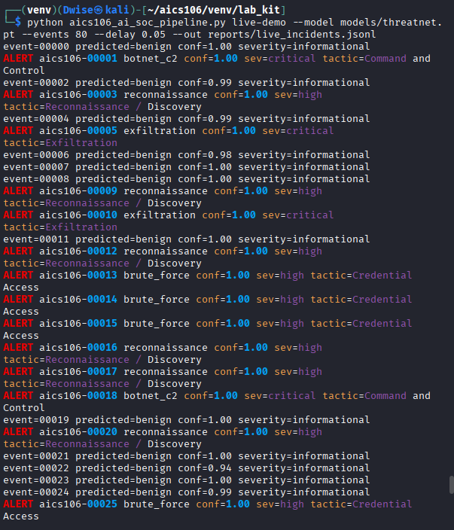
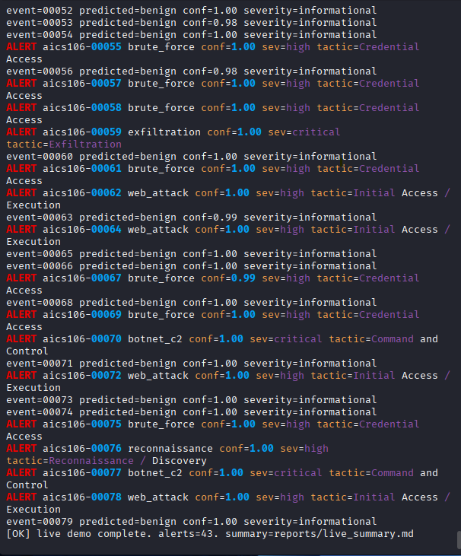

Alerts Requiring Immediate Escalation
The following alerts should be escalated immediately because they indicate a high probability of active compromise or significant business impact.
Alert |  |  |  |  |  |  |  |  |  |  |  |  |  |  |  |  | Reason for Escalation
Exfiltration |  |  |  |  |  |  |  |  |  |  |  |  |  |  |  |  | Possible unauthorized transfer of sensitive data requiring immediate containment.
Botnet C2 |  |  |  |  |  |  |  |  |  |  |  |  |  |  |  |  | Possible communication with a remote command-and-control server indicating malware activity.
Successful Brute Force |  |  |  |  |  |  |  |  |  |  |  |  |  |  |  |  | Suggests account compromise following repeated authentication failures.

Immediate Response Actions
- Isolate affected hosts if appropriate under incident response procedures.
- Block malicious IP addresses or domains.
- Disable or secure compromised user accounts.
- Preserve logs and volatile evidence for forensic analysis.
- Notify the incident response team.

Alerts That Should Be Monitored
Some alerts indicate suspicious behavior but may not immediately require containment.
Alert |  |  |  |  |  |  |  |  |  |  | Monitoring Reason
Reconnaissance |  |  |  |  |  |  |  |  |  |  | Could represent early-stage scanning or legitimate network discovery.
Low-confidence Web Attack |  |  |  |  |  |  |  |  |  |  | Requires correlation with web server logs and WAF alerts.
Single Failed Login Pattern |  |  |  |  |  |  |  |  |  |  | May be normal user error unless repeated over time.

Monitoring Actions
- Continue collecting related events.
- Correlate with firewall, IDS/IPS, EDR, and authentication logs.
- Increase logging or alert thresholds if similar events continue.
- Escalate if additional malicious indicators appear.

Technical Explanation (Own Words)
The live AI SOC detector demonstrated how machine learning can analyze streaming network telemetry in near real time. As each event was received, the ThreatNet model classified it as either benign or one of several attack categories. High-confidence detections were automatically recorded as structured incidents in a JSONL file, while an executive summary provided an overview of the detected threats and their severity. This workflow shows how AI can support SOC analysts by prioritizing alerts, reducing manual effort, and enabling faster responses to potentially malicious activity while still allowing analysts to validate and investigate the findings.

Problems Faced and Solutions
Problem |  |  |  |  |  |  |  |  |  |  |  |  |  |  |  |  |  |  |  |  |  | Solution
High event rate made manual observation difficult |  |  |  |  |  |  |  |  |  |  |  |  |  |  |  |  |  |  |  |  |  | Reduced the event delay during testing and reviewed the generated JSONL incident log after execution.
Multiple alerts occurred simultaneously |  |  |  |  |  |  |  |  |  |  |  |  |  |  |  |  |  |  |  |  |  | Used severity levels and confidence scores to prioritize the most critical incidents.
Distinguishing true attacks from suspicious but benign activity |  |  |  |  |  |  |  |  |  |  |  |  |  |  |  |  |  |  |  |  |  | Correlated AI predictions with contextual information and recommended further investigation before taking disruptive actions.
Ensuring incident reports were complete |  |  |  |  |  |  |  |  |  |  |  |  |  |  |  |  |  |  |  |  |  | Verified that each JSONL record included timestamps, confidence scores, severity, predicted class, and recommended response actions.
Live demonstration timing |  |  |  |  |  |  |  |  |  |  |  |  |  |  |  |  |  |  |  |  |  | Tested the detector before the demonstration to confirm that the model, dataset, and output paths were configured correctly.

Model Hardening, Drift, and Adversarial Thinking
The objective of this lab was to evaluate the robustness of the ThreatNet model under changing network conditions, examine how performance changes when traffic distributions shift, identify general evasion risks, and propose governance controls for secure deployment in a Security Operations Center (SOC).

Tasks Performed

1. Drift Simulation
The trained ThreatNet model was evaluated against a modified network traffic profile to simulate data drift.
python aics106_ai_soc_pipeline.py drift-test --model models/threatnet.pt --out reports/drift_test.md
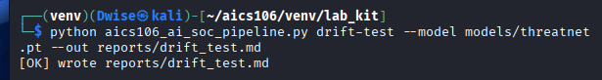

Technical Explanation (Own Words)
The drift test demonstrated that even a well-performing intrusion detection model can lose accuracy when network behavior changes over time. This reinforces the importance of monitoring production performance rather than relying solely on initial evaluation metrics. Regular retraining, continuous monitoring, and formal approval processes help maintain model effectiveness and reduce operational risk. A model risk register also provides a structured way to identify, assess, and mitigate risks associated with AI deployment in cybersecurity.
Problems Faced and Solutions
Problem |  |  |  |  |  |  |  |  |  |  |  | Solution
Performance decreased under changed traffic patterns |  |  |  |  |  |  |  |  |  |  |  | Proposed scheduled retraining and drift monitoring.
Difficulty identifying drift early |  |  |  |  |  |  |  |  |  |  |  | Recommended automated monitoring of Macro F1, precision, and recall.
Balancing security with operational stability |  |  |  |  |  |  |  |  |  |  |  | Suggested staged deployment with rollback capability and approval workflows.
Managing evolving attack behavior |  |  |  |  |  |  |  |  |  |  |  | Recommended incorporating newly validated attack samples into future training datasets.

Capstone Defense
The objective of the capstone project was to design, implement, evaluate, and demonstrate an AI-powered Security Operations Center (SOC) capable of detecting multiple categories of network threats using deep learning techniques.
tree -L 3 .
python aics106_ai_soc_pipeline.py live-demo --model models/threatnet.pt --events 30 --delay 0.02
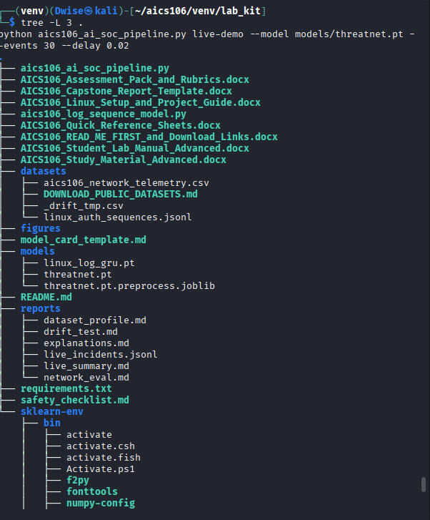
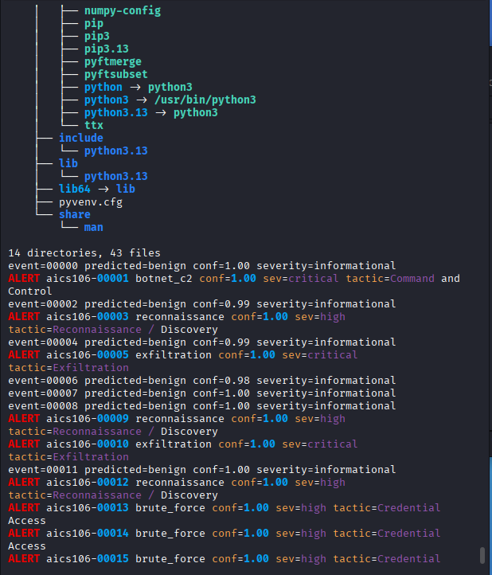
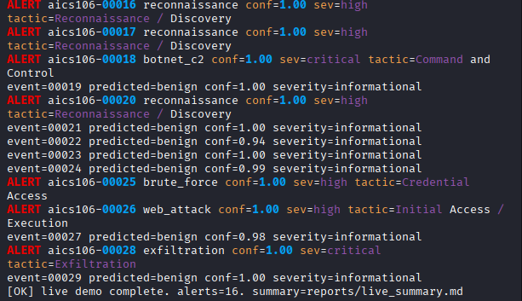

Dataset Handling
- Generated 30,000 enterprise network events.
- Six traffic classes:
  - Benign
  - Reconnaissance
  - Brute Force
  - Web Attack
  - Exfiltration
  - Botnet C2
- Applied preprocessing:
  - Missing value handling
  - One-hot encoding
  - Feature scaling
  - Stratified train/validation/test split
- Prevented data leakage by fitting preprocessing only on the training set.

Deployment Recommendation
The ThreatNet model demonstrates strong performance on the available evaluation dataset, particularly when measured using Macro F1-score. However, it should not be deployed as a fully autonomous security control. Instead, it is best suited as a decision-support system within a SOC, where it assists analysts by prioritizing alerts, providing explainable predictions, and generating incident reports. Before production deployment, the model should undergo testing with representative real-world traffic, continuous monitoring for performance drift, and periodic retraining using validated data.

Technical Explanation (Own Words)
This capstone project demonstrates how artificial intelligence can enhance cybersecurity operations by automating the detection of multiple categories of network attacks. The solution combines data preprocessing, deep learning, explainability, and live incident reporting into a complete SOC pipeline. Evaluation using Macro F1-score, confusion matrices, and explainability techniques provided a more comprehensive assessment than accuracy alone. Although the model achieved strong results on the evaluation dataset, ongoing monitoring, human oversight, and governance are essential to ensure reliable performance in operational environments.
Problems Faced and Solutions
Problem |  |  |  |  |  |  |  |  |  |  |  |  | Solution
Managing multiple stages of the AI SOC pipeline |  |  |  |  |  |  |  |  |  |  |  |  | Organized the project into separate modules for data generation, preprocessing, training, evaluation, explainability, and live detection.
Preventing data leakage |  |  |  |  |  |  |  |  |  |  |  |  | Applied preprocessing only to the training data and used stratified dataset splitting.
Evaluating model performance fairly |  |  |  |  |  |  |  |  |  |  |  |  | Used Macro F1-score, per-class metrics, confusion matrices, and error analysis in addition to overall accuracy.
Maintaining model reliability over time |  |  |  |  |  |  |  |  |  |  |  |  | Proposed drift monitoring, scheduled retraining, and model governance controls.
Determining deployment readiness |  |  |  |  |  |  |  |  |  |  |  |  | Recommended deployment as a decision-support tool with human analyst oversight rather than a fully autonomous security solution.

Executive Summary
This project developed an AI-powered Security Operations Center (SOC) detector capable of identifying multiple categories of enterprise network threats using deep learning. The system processes network telemetry, performs preprocessing, classifies traffic using a Deep Residual ThreatNet model, generates explainable predictions, and produces structured incident reports for analysts.
The detector supports the identification of six traffic categories:
- Benign
- Reconnaissance
- Brute Force
- Web Attack
- Exfiltration
- Botnet Command-and-Control (C2)
The system also includes:
- Explainable AI (feature importance)
- Live streaming detection
- JSONL incident generation
- Executive summary reports
- Drift testing
- Model risk assessment
However, the detector is not intended to replace human analysts. It does not perform digital forensics, malware reverse engineering, or autonomous incident response. Predictions should always be validated by SOC analysts before operational actions are taken.

Data

Dataset Source
A synthetic enterprise network telemetry dataset was generated using the provided AI SOC pipeline.
Dataset Size
Property |  |  |  |  |  |  |  |  |  |  |  |  |  |  |  |  |  |  |  |  |  |  |  |  |  |  |  |  |  |  |  |  |  |  |  |  |  |  |  |  |  |  |  |  |  |  |  |  |  |  |  |  |  |  |  |  |  | Value
Total Events |  |  |  |  |  |  |  |  |  |  |  |  |  |  |  |  |  |  |  |  |  |  |  |  |  |  |  |  |  |  |  |  |  |  |  |  |  |  |  |  |  |  |  |  |  |  |  |  |  |  |  |  |  |  |  |  |  | 30,000
Attack Classes |  |  |  |  |  |  |  |  |  |  |  |  |  |  |  |  |  |  |  |  |  |  |  |  |  |  |  |  |  |  |  |  |  |  |  |  |  |  |  |  |  |  |  |  |  |  |  |  |  |  |  |  |  |  |  |  |  | 6
Features |  |  |  |  |  |  |  |  |  |  |  |  |  |  |  |  |  |  |  |  |  |  |  |  |  |  |  |  |  |  |  |  |  |  |  |  |  |  |  |  |  |  |  |  |  |  |  |  |  |  |  |  |  |  |  |  |  | 15
Missing Values |  |  |  |  |  |  |  |  |  |  |  |  |  |  |  |  |  |  |  |  |  |  |  |  |  |  |  |  |  |  |  |  |  |  |  |  |  |  |  |  |  |  |  |  |  |  |  |  |  |  |  |  |  |  |  |  |  | 0

Dataset Schema
Feature |  |  |  |  |  |  |  |  |  |  |  |  |  |  |  |  |  |  |  |  |  |  |  |  |  |  |  |  |  |  |  |  |  |  |  |  |  |  |  |  |  |  |  |  |  |  |  |  | Description
src_ip |  |  |  |  |  |  |  |  |  |  |  |  |  |  |  |  |  |  |  |  |  |  |  |  |  |  |  |  |  |  |  |  |  |  |  |  |  |  |  |  |  |  |  |  |  |  |  |  | Source IP address
dst_ip |  |  |  |  |  |  |  |  |  |  |  |  |  |  |  |  |  |  |  |  |  |  |  |  |  |  |  |  |  |  |  |  |  |  |  |  |  |  |  |  |  |  |  |  |  |  |  |  | Destination IP address
src_port |  |  |  |  |  |  |  |  |  |  |  |  |  |  |  |  |  |  |  |  |  |  |  |  |  |  |  |  |  |  |  |  |  |  |  |  |  |  |  |  |  |  |  |  |  |  |  |  | Source port
dst_port |  |  |  |  |  |  |  |  |  |  |  |  |  |  |  |  |  |  |  |  |  |  |  |  |  |  |  |  |  |  |  |  |  |  |  |  |  |  |  |  |  |  |  |  |  |  |  |  | Destination port
protocol |  |  |  |  |  |  |  |  |  |  |  |  |  |  |  |  |  |  |  |  |  |  |  |  |  |  |  |  |  |  |  |  |  |  |  |  |  |  |  |  |  |  |  |  |  |  |  |  | Network protocol
packet_size |  |  |  |  |  |  |  |  |  |  |  |  |  |  |  |  |  |  |  |  |  |  |  |  |  |  |  |  |  |  |  |  |  |  |  |  |  |  |  |  |  |  |  |  |  |  |  |  | Packet size
duration |  |  |  |  |  |  |  |  |  |  |  |  |  |  |  |  |  |  |  |  |  |  |  |  |  |  |  |  |  |  |  |  |  |  |  |  |  |  |  |  |  |  |  |  |  |  |  |  | Connection duration
bytes_sent |  |  |  |  |  |  |  |  |  |  |  |  |  |  |  |  |  |  |  |  |  |  |  |  |  |  |  |  |  |  |  |  |  |  |  |  |  |  |  |  |  |  |  |  |  |  |  |  | Outbound traffic
bytes_received |  |  |  |  |  |  |  |  |  |  |  |  |  |  |  |  |  |  |  |  |  |  |  |  |  |  |  |  |  |  |  |  |  |  |  |  |  |  |  |  |  |  |  |  |  |  |  |  | Inbound traffic
packets |  |  |  |  |  |  |  |  |  |  |  |  |  |  |  |  |  |  |  |  |  |  |  |  |  |  |  |  |  |  |  |  |  |  |  |  |  |  |  |  |  |  |  |  |  |  |  |  | Packet count
tcp_flags |  |  |  |  |  |  |  |  |  |  |  |  |  |  |  |  |  |  |  |  |  |  |  |  |  |  |  |  |  |  |  |  |  |  |  |  |  |  |  |  |  |  |  |  |  |  |  |  | TCP flags
failed_logins |  |  |  |  |  |  |  |  |  |  |  |  |  |  |  |  |  |  |  |  |  |  |  |  |  |  |  |  |  |  |  |  |  |  |  |  |  |  |  |  |  |  |  |  |  |  |  |  | Failed login attempts
request_rate |  |  |  |  |  |  |  |  |  |  |  |  |  |  |  |  |  |  |  |  |  |  |  |  |  |  |  |  |  |  |  |  |  |  |  |  |  |  |  |  |  |  |  |  |  |  |  |  | Requests per second
dns_queries |  |  |  |  |  |  |  |  |  |  |  |  |  |  |  |  |  |  |  |  |  |  |  |  |  |  |  |  |  |  |  |  |  |  |  |  |  |  |  |  |  |  |  |  |  |  |  |  | Number of DNS requests
label |  |  |  |  |  |  |  |  |  |  |  |  |  |  |  |  |  |  |  |  |  |  |  |  |  |  |  |  |  |  |  |  |  |  |  |  |  |  |  |  |  |  |  |  |  |  |  |  | Traffic category

Data Cleaning
The following preprocessing steps were applied:
- Removed duplicate records
- Checked for missing values
- Standardized feature formats
- Separated categorical and numerical features
- One-hot encoded categorical variables
- Standardized numerical variables
- Created reusable preprocessing pipeline

Class Imbalance
The dataset contains more benign traffic than attack traffic, reflecting realistic enterprise environments.
To reduce bias during training:
- Class weighting was enabled.
- Focal Loss emphasized difficult and minority-class examples.
- Macro F1-score was used as the primary evaluation metric.

Operational Interpretation
The model demonstrates strong overall performance while maintaining balanced detection across minority attack classes. However, certain attack categories remain more difficult to distinguish because they share similar traffic characteristics. The detector should therefore be used to assist analysts rather than to automate incident response.

Risk Assessment

Bias
Synthetic datasets may not fully represent real enterprise environments, potentially limiting generalization.

Drift
Changes in network behavior can reduce model performance over time. Continuous monitoring and scheduled retraining are recommended.

Privacy
Telemetry should be collected and stored according to organizational policies, with access controls and data minimization applied where appropriate.

False Positives
False positives may increase analyst workload and contribute to alert fatigue.

False Negatives
Missed attacks may allow malicious activity to continue undetected, potentially leading to greater organizational impact.

Approval Workflow
Before deployment, the model should pass:
- Technical validation.
- Security review.
- Performance evaluation on representative data.
- Management approval.
- Controlled pilot deployment with ongoing monitoring.

Conclusion
The Deep Residual ThreatNet model achieved strong performance in detecting six categories of enterprise network activity. By combining preprocessing, class weighting, Focal Loss, explainability, and live incident reporting, the system demonstrates the practical application of AI within a SOC environment.
The model is appropriate for laboratory and educational use and is a suitable candidate for a pilot deployment under analyst supervision. It should not be deployed as a fully autonomous security control until it has been validated with representative production data, integrated with operational monitoring, and supported by formal governance and retraining processes.
Overall, the project demonstrates how AI can improve SOC efficiency by prioritizing alerts, providing transparent predictions, and assisting analysts in identifying potential cyber threats while preserving human oversight for operational decision-making.

